**Assignment 8**

**Problem Statement:**

You work for a corporation. Their application requires a storage service that can store files and publicly share them if required. Implement S3 for the same.

**Tasks To Be Performed:**

1. Create an S3 Bucket for file storage.

2. Upload 5 objects with different file extensions.

**Solution:**

Step 1:- Create S3 bucket

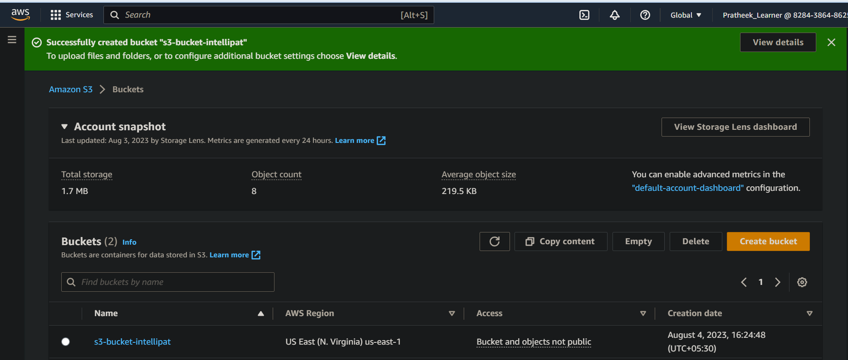

Step 2:- Upload 5 objects

